Carmen Mendoza

CSD 402

Link to GitHub repository:

<https://github.com/cmendoza-cloud/CSD402.git>

Screenshot of GitHub repository:

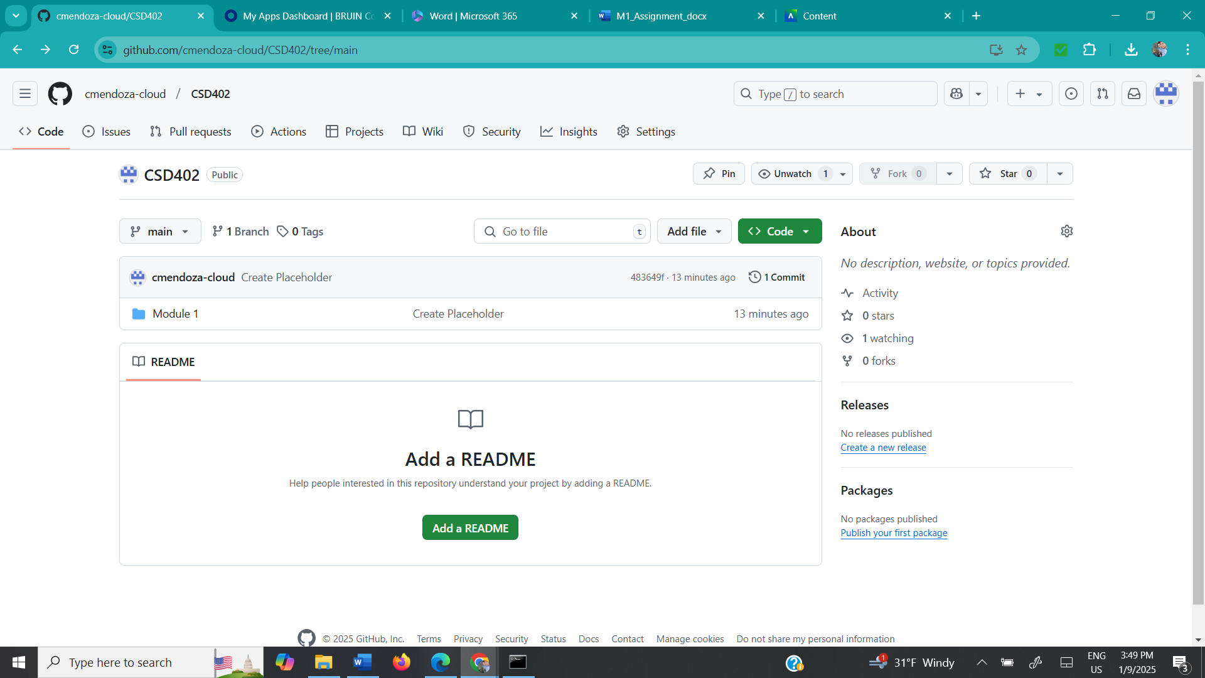

Screenshot of local directory (properly formatted):

